Weekly Status Report to O2O Technologies – Mobile Web UI Development

Duration | 31-Dec-2018 to 4-Jan-2019

Document Summary
Author: Amit Balpathak
Revision Date: January 4, 2019
Customer Reference:
Distribution: Vineeth Narasimhan & SpringCT

Document Created By:

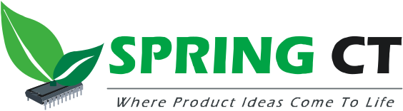

Spring Computing Technologies Pvt. Ltd.

Vijay Commercial Complex, 3rd Floor
Near Guruganesh Nagar, D P Road,
Kothrud, Pune 411 038, India

Phone: +91 20 25391316/19
Fax: +91 20 25391335

http://www.springct.com/

Week 03

Tasks completed this week
Task completed | Remarks
Project setup | Done
Captured KYC details from competitor’s app and presented Vineeth with the approach for Kristal Mobile Web UI. Focus is to shorten the KYC process. | Done
Wireframes concept (Sign up and KYC) for Singapore | Done

Tasks planned but not completed this week
Task not completed | Reasons / Comments
API understanding | Need walkthrough from Kristal team
Wireframes for rest of the steps in the process (Singapore)

Plan for the next week
Tasks | Remarks / dependencies
Visual designs for Sign up and KYC flows for Singapore. | UX team is working on few changes suggested by Vineeth in Friday’s call. After these changes team will start with visual designs from Monday.
Create document on APIs that needs to be changed
Start UI development – Sign up and KYC flows

Schedule slips and recovery actions

– None

Key milestones for the project
No | Milestone | Planned Date | Actual Date | Remarks
 | Milestone #1 –  SpringCT will complete requirement understanding and prepare UX Design (wireframes and visual designs). | 4-Jan-2018

